FreeETarget
Application Note: Timed Fire Events

CAUTION

When using FreeETarget:

- Wear eye protection
- Maintain a safe distance
- Do not shoot into any areas except the open target areas.

The freeETarget project or contributors will not be responsible for any injuries when using this target of it’s components.

Target shooting can be dangerous so apply caution in everything you do.

SUMMARY

In addition to the conventional course of fire, FreeETarget supports timed events

- Rapid Fire Pistol,
- Rapid Fire Sport Pistol
- Tabata Training

Required

The following are required to use the timed events with FreeETarget

- PC Client, Version 4.12.2 or higher
- Target Firmware 6.4.2 or higher
Optional

- Timed Fire Traffic Lights https://free-e-target.com/service-documents/#TimedFireTrafficLights

Rapid Fire Pistol

Rapid fire pistol is the event where the athlete has a short period of time to fire a number of shots into the target. The event is controlled by the Events Tab in the settings.

Figure 1 shows the settings for the Rapid Fire Pistol

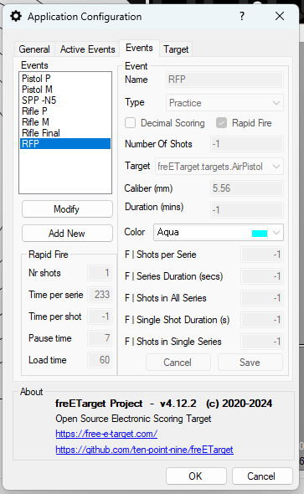 | Name: RFP  Target: Choose the target used for this relay  Check Rapid Fire  Nr shots. The number of times the event is repeated. Typically set to 1  (Note: Each series is typically 5 shots long)  Time per series. How long the event runs in seconds.  Pause time. How long the athlete is warned before the event time is active  Load time. How long the athlete is given to prepare for the event
Figure 1: Rapid Fire Pistol Settings

Typical Values

Event | Nr shots | Time per series | Pause time | Load time | Shot Override
NRA Timed Fire | 1 | 60 | 10 | 60 | -N10
NRA Rapid Fire | 1 | 10 | 10 | 60 | -N10
ISSF Timed Fire | 1 | 233 | 10 | 60

Sport Rapid Fire Pistol

Sport Rapid Fire Pistol differs from Rapid fire pistol in that the athelete is presented with a number of targets all spaced apart in time and they have a short period of time to put one shot into the target.

Figure 2 shows the settings for the Sport Rapid Fire Pistol

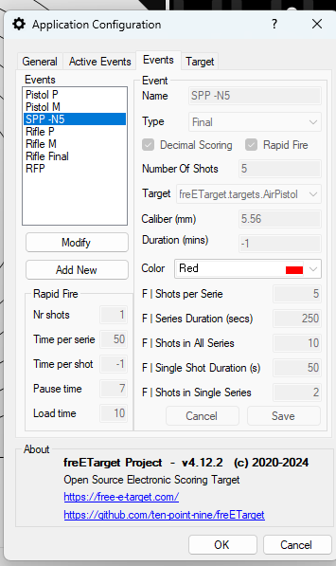 | Name: RFP  Target: Choose the target used for this relay  Check Rapid Fire  Nr shots. The number of times the event is repeated. Typically set to 1  (Note: Each series is typically 5 shots long)  Time per series. How long the event runs in seconds.  Pause time. How long the athlete is warned before the event time is active  Load time. How long the athlete is given to prepare for the event  In this example, the athlete has 50 seconds to lay down 5 shots. This is made up as  50 = 5 x ( 7 second pause + 3 seconds live)  The 3 second live time is calculated based on the 5, 50, and 7 settings
Figure 2: Sport Rapid Fire Pistol Settings

Typical Values

Event | Nr shots | Time per series | Pause time | Load time | Shot Override
Timed Fire | 1 | 50 | 7 | 60 | -N5
Tabata

Tabata is a training aid to control the amount of time an athlete has on the target to make a shot.

Figure 3 shows the settings for the Tabata

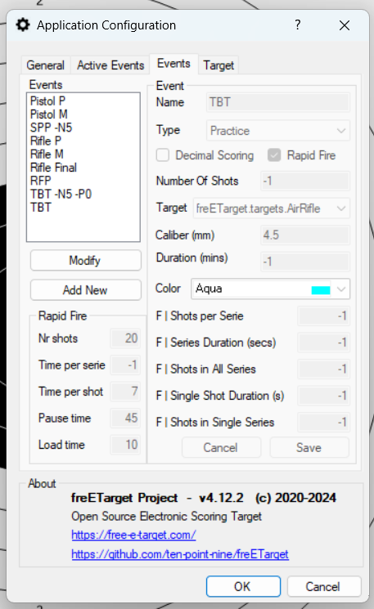 | Name: TBT  Target: Choose the target used for this relay  Check Rapid Fire  Nr shots. The number of times the event is repeated. Typically set to 20  (Note: Each series is 1 shot long)  Time per shot. How long the target is active for. Typically less than 7 seconds.  Pause time. How long between shots  Load time. How long the athlete is given to prepare for the event  In this example, the athlete will be presented with 20 shots that are active for 7 seconds, and then a 45 second break to reload and prepare.
Figure 3: Tabata Settings

Overrides

You can tailor each event by adding overrides to its name.

Overrides are applied to the event name, for example, SPP -N6 allows six shots instead of the standard five.

Overrides may be applied to ANY event to create special purpose training events.

The overrides are presented below.

Override | Description | Purpose | Example
-N | Number of shots in the event | Tailor the number of shots to a specific event | -N5 Five shots will be fired in one event
-P | Override {“PAPER_TIME”:0} | Temporarily disable the witness paper drive during the event | -P0 Do not advance the paper when a shot is fired
-E | Override {“PAPER_ECO”:0} | Expand the PAPER_ECO for the event | -E30 Temporarily set the PAPER_ECO to 30mm

